Research Methods

Theme: Third World Developing Countries (Industry 4.0)

by

Heider Jeffer

Supervisor Prof. Barbara Russo

Date(s): 2018 January 10th   
Document status: Proposed

# Theme: Third World Developing Countries (Industry 4.0)

# How we use Industry 4.0 in third world developing countries (e.g. Iraq)

# Question:

1. How do we use Industry 4.0 in third world countries (e.g Iraq)?

## Keywords:

* Third World Countries
* Cyber Physical Systems
* Indstrial Technology
* Manfucturing
* Industry 4.0

# Inclusion/Exclusion:

* inclusion:
  + Scientific papers published in journals/conferences
  + Scientific papers accessible electronically
  + Books
  + Case studies
* exclusion:
  + Slides, websites, blogs
  + Scientific papers not available in English
  + Scientific papers less than 2 pages

# List of papers

|  |  |  |  |
| --- | --- | --- | --- |
| **NO.** | **Research Name** | **Keywords** | **Link** |
| 1. | Communication middleware technologies for industrial distributed control systems: A literature review | Industry 4.0, Industrial technology (Validation research) | <http://ieeexplore.ieee.org/document/8247730/> |
| 2. | Advanced manufacturing solution to industry 4.0 trend through sensing network and Cloud Computing technologies | Industry 4.0, Manufacturing  (Solution proposal) | <http://ieeexplore.ieee.org/document/6899471/> |
| 3. | Integration of agent technology into manufacturing enterprise: A review and platform for industry 4.0 | Industry 4.0, Manufacturing  (Evaluation research) | <http://ieeexplore.ieee.org/document/7093910/> |
| 4. | Intelligent manufacturing — Chinese industry 4.0 | Industry 4.0, Manufacturing  (Evaluation research) | <http://ieeexplore.ieee.org/document/7285366/> |
| 5. | Industry 4.0 with cyber-physical integration: A design and manufacture perspective | Industry 4.0, Manufacturing  (Evaluation research) | <http://ieeexplore.ieee.org/document/7313954/> |
| 6. | Geographic Information Science and technology as key approach to unveil the potential of Industry 4.0: How location and time can support smart manufacturing Sign In or Purchase | Industry 4.0, Manufacturing  (Solution proposal) | <http://ieeexplore.ieee.org/document/7347812/> |
| 7. | Bespoke muesli sets industry 4.0 on its way [Manufacturing Digitisation] | Industry 4.0, Manufacturing  (Solution proposal) | <http://ieeexplore.ieee.org/document/7590517/> |
| 8. | Manufacturing Ontology Development Based on Industry 4.0 Demonstration Production Line | Industry 4.0, Manufacturing  (Solution proposal) | <http://ieeexplore.ieee.org/document/7780224/> |
| 9. | Industry 4.0 Development and Application of Intelligent Manufacturing | Industry 4.0, Manufacturing  (Evaluation research) | <http://ieeexplore.ieee.org/document/7816745/> |
| 10. | A literature review on variability in semiconductor manufacturing: The next forward leap to Industry 4.0 | Industry 4.0, Manufacturing  (Validation research) | <http://ieeexplore.ieee.org/document/7822298/> |
| 11. | Mobile Services for Customization Manufacturing Systems: An Example of Industry 4.0 | Industry 4.0, Manufacturing  (Evaluation research) | <http://ieeexplore.ieee.org/document/7750610/> |
| 12. | CASOA: An architecture for agent-based manufacturing system in the context of Industry 4.0 | Industry 4.0, Manufacturing  (Solution proposal) | <http://ieeexplore.ieee.org/document/8053743/> |
| 13. | Cyber-physical system integration for industry 4.0: Modelling and simulation of an induction heating process for aluminium-steel molds in footwear soles manufacturing | Industry 4.0, Manufacturing  (Solution proposal) | <http://ieeexplore.ieee.org/document/8065972/> |
| 14. | From Intelligent Manufacturing to Smart Manufacturing for Industry 4.0 Driven by Next Generation Artificial Intelligence and Further On | Industry 4.0, Manufacturing  (Evaluation research) | <http://ieeexplore.ieee.org/document/8119409/> |
| 15. | Self-Organizing Manufacturing: Current Status and Prospect for Industry 4.0 | Industry 4.0, Manufacturing  (Evaluation research) | <http://ieeexplore.ieee.org/document/8119410/> |
| 16. | Big Data in Wisdom Manufacturing for Industry 4.0 | Industry 4.0, Manufacturing  (Solution proposal) | <http://ieeexplore.ieee.org/document/8119375/> |
| 17. | Robot control and decision making through real-time sensors monitoring and analysis for industry 4.0 implementation on aerospace component manufacturing | Industry 4.0, Manufacturing  (Solution proposal) | <http://ieeexplore.ieee.org/document/8121928/> |
| 18. | Security trends and advances in manufacturing systems in the era of industry 4.0 | Industry 4.0, Manufacturing  (Evaluation research) | <http://ieeexplore.ieee.org/document/8203896/> |
| 19. | Simulation-based dynamic shop floor scheduling for a flexible manufacturing system in the industry 4.0 environment | Industry 4.0, Manufacturing  (Solution proposal) | <http://ieeexplore.ieee.org/document/8248101/> |
| 20. | Intelligent sensing for robotic re-manufacturing in aerospace — An industry 4.0 design based prototype | Industry 4.0, Manufacturing  (Solution proposal) | <http://ieeexplore.ieee.org/document/8250134/> |
| 21. | Digital Twin and Big Data Towards Smart Manufacturing and Industry 4.0: 360 Degree Comparison | Industry 4.0, Manufacturing  (Evaluation research) | <http://ieeexplore.ieee.org/document/8258937/> |
| 22. | Industry 4.0: Advances of Germany's manufacturing innovation | Industry 4.0, Manufacturing  (Evaluation research) | <http://ieeexplore.ieee.org/document/8256152/> |
| 23. | Agile Factory - An Example of an Industry 4.0 Manufacturing Process | Industry 4.0, Manufacturing  (Validation research) | <http://ieeexplore.ieee.org/document/7272683/> |
| 24. | Selection of a data exchange format for industry 4.0 manufacturing systems | Industry 4.0, Manufacturing (Evaluation research) | <http://ieeexplore.ieee.org/document/7793750/> |
| 25. | State of product detection method applicable to Industry 4.0 manufacturing models with small quantities and great variety | Industry 4.0, Manufacturing  (Evaluation research) | <http://ieeexplore.ieee.org/document/7988251/> |
| 26. | Modeling business motivation and underlying processes for RAMI 4.0-aligned cyber-physical production systems | Industry 4.0, Cyber Physical Systems  (Solution proposal) | <http://ieeexplore.ieee.org/document/8247702/> |
| 27. | Big data as a promoter of industry 4.0: Lessons of the semiconductor industry | Industry 4.0, Cyber Physical Systems  (Validation research) | <http://ieeexplore.ieee.org/document/8104778/> |
| 28. | Cyber physical systems in the context of Industry 4.0 | Industry 4.0, Cyber Physical Systems (Evaluation research) | <http://ieeexplore.ieee.org/document/6857843/> |
| 29. | A cyber-physical architecture for industry 4.0-based power equipments detection system | Industry 4.0, Cyber Physical Systems  (Solution proposal) | <http://ieeexplore.ieee.org/document/7757942/> |
| 30. | An improved Cyber-Physical Systems architecture for Industry 4.0 smart factories | Industry 4.0, Cyber Physical Systems  (Solution proposal) | <http://ieeexplore.ieee.org/document/7988589/> |
| 31. | A BPMN extension for modeling Cyber-Physical-Production-Systems in the context of Industry 4.0 | Industry 4.0, Cyber Physical Systems  (Validation research) | <http://ieeexplore.ieee.org/document/8000159/> |
| 32. | Cyber-physical system integration for industry 4.0: Modelling and simulation of an induction heating process for aluminium-steel molds in footwear soles manufacturing | Industry 4.0, Cyber Physical Systems  (Validation research) | <http://ieeexplore.ieee.org/document/8065972/> |
| 33. | The impact of dynamic spectrum access network on third world countries: spectrum allocation issues, network and economic growth (the African tale) | Industry 4.0, Third World Countries  Evaluation research | <http://ieeexplore.ieee.org/document/1542618/> |
| 34. | Third World electrification (with Industry 4.0) | Industry 4.0, Third World Countries  (Solution proposal) | <http://ieeexplore.ieee.org/document/4648541/> |
| 35. | Is Remote Sensing An Economic Tool In Third World Countries? | Industry 4.0, Third World Countries  (Opinion paper) | <http://ieeexplore.ieee.org/document/577929/> |

# Classification scheme

## Research type:

* 1. Evaluation research
  2. Validation research
  3. Solution proposal
  4. Opinion paper

## Bubble plot

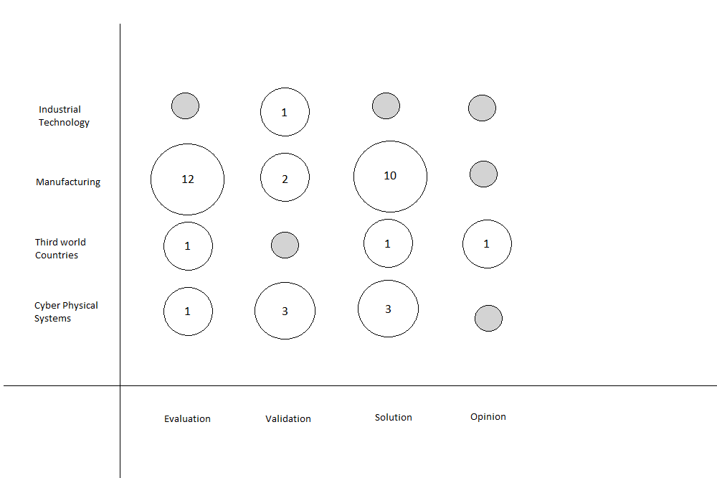

# Question and Answers

* Question 1: Is it possible to use the industry 4.0 in developing countries?

Answer 1: Yes. Systems used industry 4.0 technologies to establish a lot of projects to help developing countries in the middle east, for example the airport control system in Lebanon.

* Question 2: Smart city. Is there a way to implement the smart city approach to protect Iraqi borders from the external attacks and threats?

Answer 2: Yes, it is possible, for protecting and controlling the borders with Lebanon Syria and Israel, smart approaches can be used to minimize human involvement at threat-prone spots.

* Question 3: Is it possible to use industry 4.0 technology to build secure communication in the army?  
    
  Answer 3: Yes, using a lot of sensors and encrypted communication channels it is possible to use industry 4.0 technology to build secure communication in the army.